Lab sheet 10

IT23684126

Question 01

i. 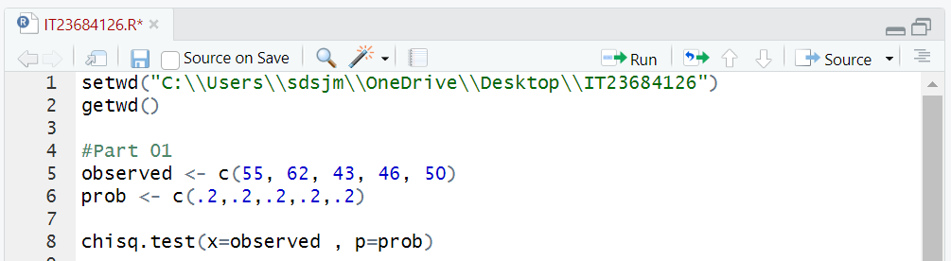

ii.

Question 02

i.

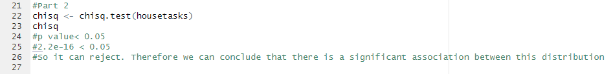ii.

Exercise

